**Purchase Order Contract**

**Ercan Agilli** herein after called the “First Party/Buyer”, and **Hebei Kangshuo Wire Mesh Manufacture Co., Ltd.** herein after called the “Second Party/Manufacturer” agrees to enter into this Purchasing Order Contract under the terms and conditions set here below.

**Production & Description of goods**The Second Party agrees to produce/prepare the following goods (120 pc of “Customized Kangshuo Cold Smoke Generator for Smoker Barbecue Grill Cooking Tools for Bacon”) in described conditions here below (without logo).   
The color definitions and model numbers of which are based on the portfolio provided by The Second Party  
based on Proforma Invoice no KS18-1-17A1;

* Each piece should have the size specified as 21cm*18cm*4cm and in round shape(without box).
* Silver color and stainless steel material to be used.
* Each piece should have the grid wire diameter of 1*2 mesh (exactly shown in the expected photos below)
* All pieces should be packaged pp bag, wood carton, plain.
* Total of 3 cartons (40 pieces/carton, 120 pieces in total)
* 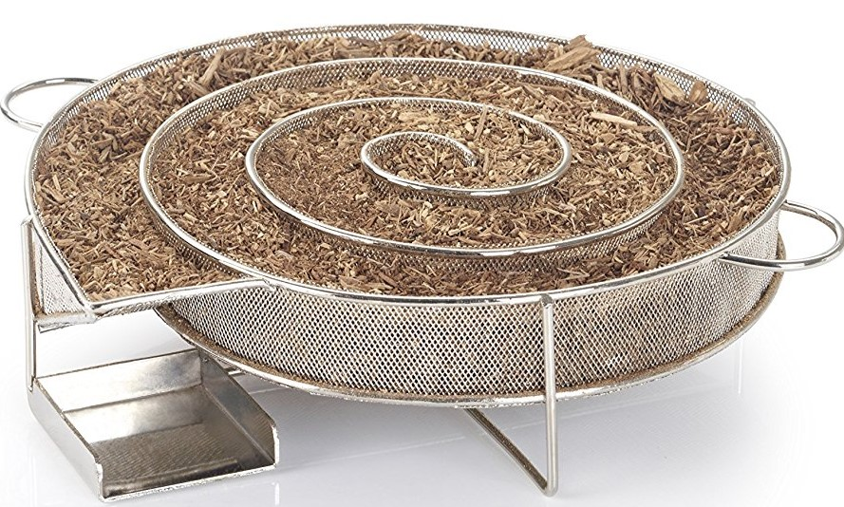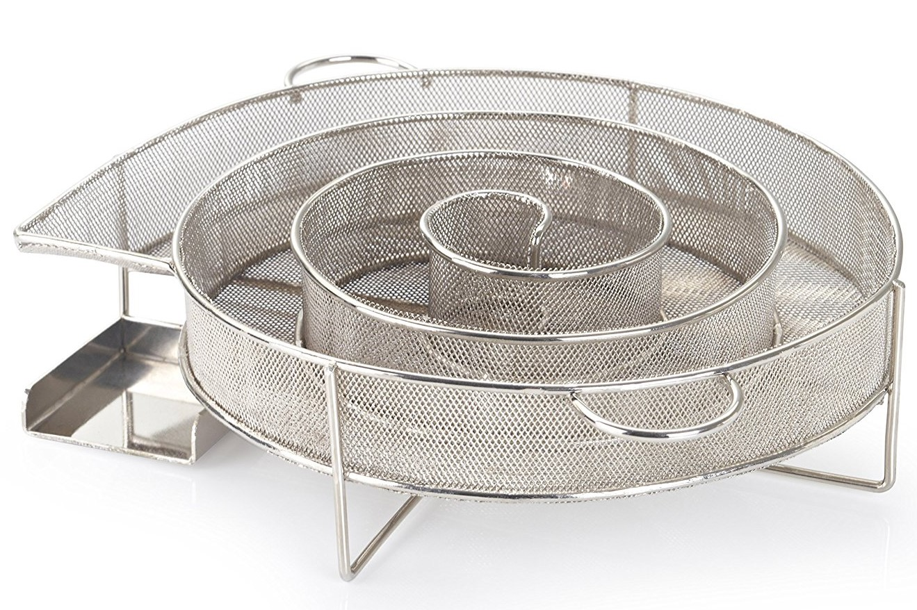Each cargo box should be labeled with labels, including the correct shipping information provided by First Party.

The expected photos of product:  
  
  
  
  
  
  
  
  
  
  
  
  
  
  
  
  
  
  
  
  
**Cargo readiness**Cargo is to be ready for shipment within 10 days upon receipt of advance payment. If production/preparation time exceeds the agreed upon production time – the First Party requires advanced notification of at least 2 days in order to respond appropriately.  If production is delayed by more than 10 days without agreed upon conditions, the First Party reserves the right to enforce a 5% discount on the order for every 10 days that production is delayed.

If there are any flaws discovered during production that do not meet the agreed upon specifications, the Second Party agrees to discount products, fix flaws, or replace the units. The course of action if flaws arise is to be determined at the sole discretion of the First Party. The First Party will make every effort to find an agreeable solution to maintain a quality relationship with the Second Party and expects the same in good faith.  
  
If the product does net meet the agreed upon specification, The Second Party agrees to receive back the entire of products by paying the shipping and all required charges without any excuse.

**Payment**  
Total amount: USD **1246**  
Advance payment of 30% (USD$ **373.8**) due immediately upon signing of contract by both parties.  
Balance amount, 70%, (USD$ **872.2**) due at cargo readiness date.

Transfer of amounts to be made to below beneficiary details;

Beneficiary’s name: KE SHAOTAO

Beneficiary’s Bank: BANK OF CHINA HEBEI BRANCH ANPING SUB-BRANCH

Address：WEIMIN STREET, ANPING COUNTY,HENGSHUI CITY,HEBEI PROVINCE

Account: b21bb15009000053870

Swift code:BKCHCNBJ220

This agreement is entered into on 19 January, 2018

**Date : 19 January, 2018 DATE : …………………………………**

**Buyer : Ercan AGILLI SELLER : …………………………….**